T & T Book Award Placement
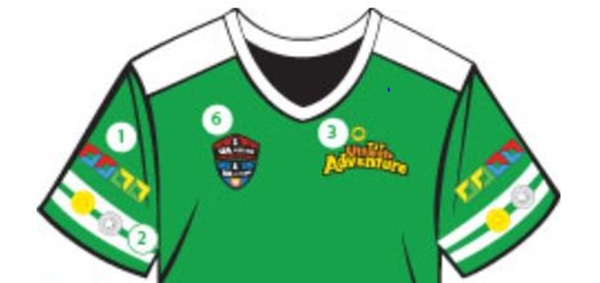
2



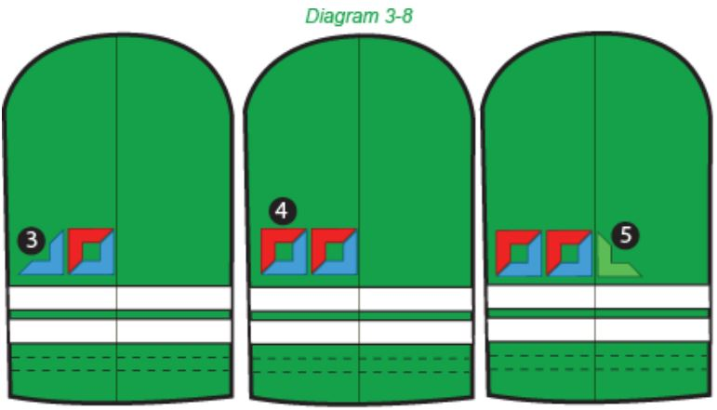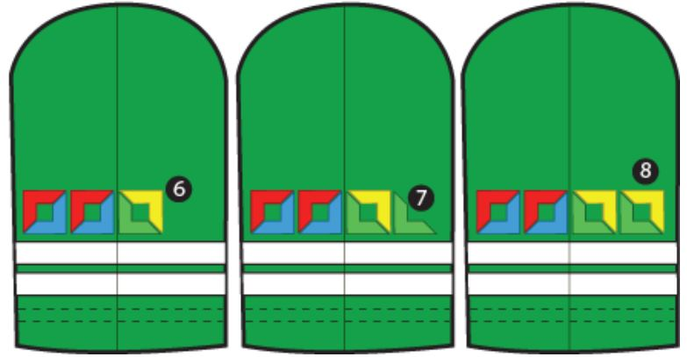
Sections | 3^{rd,} 5th grade (right sleeve)
SZ 1.1, 1.2 | Red top patch starts square at right side of right crease
1.3-1.6 | Red top corner patch starts square right of other square
2.1-2.4 | Blue lower corner patch finishes sleeve square
2.5-2.8 | Blue lower corner patch finishes far right square
3.1-3.4 | Green lower starts square at left side of right crease
3.5-3.8 | Green lower corner starts patch far left square
4.1-4.4 | Yellow top corner patch finishes square at right crease
4.5-4.8 | Yellow top corner patch finishes square far left of crease

Sections | 4th, 6th grade (left sleeve)
SZ 1.1, 1.2 | Red top patch starts square at left side of left crease
1.3-1.6 | Red top corner patch starts square left of other square
2.1-2.4 | Blue lower corner patch finishes sleeve square
2.5-2.8 | Blue lower corner patch finishes far left square
3.1-3.4 | Green lower corner starts square at right crease
3.5-3.8 | Green lower corner starts far right square left sleeve
4.1-4.4 | Yellow top corner patch finishes square right crease left
4.5-4.8 | Yellow top patch finishes square far right of crease left

How to Attach Award Emblems to Awana Uniforms

Awana awards motivate boys and girls to learn more about God’s Word. We encourage parents / guardians to consider all three methods detailed below for attaching emblems.

1. SEW - While more time-consuming, sewing is the best method to ensure that emblems stay on!

2. IRON - Note: Following instructions are for ironing on cotton/polyester fabric
- Place a thin cloth (pillow case or linen dishtowel) on ironing board (or hard surface).
- Position area of garment on the pressing cloth where the emblem is to be attached.
- Put emblem on the uniform fabric in the correct position.
- Cover the emblem with a thin cloth (pillow case or linen dish towel). Apply a hot iron at the hottest setting with as much pressure as you can for 60 seconds.
- Turn the garment over, repeat steps four, five without allowing garment to cool, move the pressing cloth to new positions on the emblem (to prevent scorching).
If the emblem loosens, repeat steps 4 through 6.

3. USE BADGE MAGIC®
Caution: Badge Magic is non-toxic, but very sticky- don’t allow children to attempt this process. Keep adhesive out of the hair, ears, nose, and mouth. Unwanted adhesive can be removed with fingers, or stain remover (Goo Gone® or WD-40®).

- WASH and dry new uniforms, and iron before applying emblems for a smooth surface. Find the emblem outlines on the Badge Magic sheet that matches the emblem to attach.
- Peel the paper cover from the selected emblem outline to reveal the sticky adhesive surface. Hint: Bending the adhesive sheet at the edge of the emblem outline will expose an edge of the paper cover. Lift it with a fingernail.
- Push the back of the emblem onto the exposed adhesive inside the emblem outline area. Press down firmly on the emblem including edges, to ensure the adhesive sticks evenly.
- PEEL the emblem from the sheet. The adhesive is now on the back of the emblem. Handle it by the edges. Tuck any excess adhesive onto the back of the emblem.
- Place the emblem gently onto the garment at the desired location. When the emblem is in exactly the right place, press it down very firmly, especially around the edges.
- Turn the garment over and rub it hard from the back side, again applying extra pressure to the edges of the emblems. Pushing down with a solid object like the handle of your scissors will help to create a stronger bond.
- DO NOT IRON! Ironing may push the adhesive all the way through the fabric, making it more difficult to remove later.
- If an emblem ever does start to peel up, it can be reattached by cutting a little adhesive from an unused part of the Badge Magic sheet, peeling off the paper backing and applying the exposed adhesive onto the loose area of the emblem. Then press the emblem firmly into place.
- TO WASH – Machine wash the garment only in cold water. Wash it separately from other clothes the first time it is washed. Tumble dry on a warm, not hot, setting. DO NOT DRY CLEAN.
- TO REMOVE – Spray Goo Gone® on the back side of the emblem. After 30 seconds, slowly peel off the emblem. To remove all the emblems at once, have the uniform dry cleaned using the traditional “Perc” solvent method. See BadgeMagic.com for additional removal details and instructional videos.

Note: Machine wash the garment only in cold water. Wash it separately from other clothes the first time it is washed. Tumble dry on a warm, not hot, setting. DO NOT DRY CLEAN.

